Caterpillar Classroom
Handbook

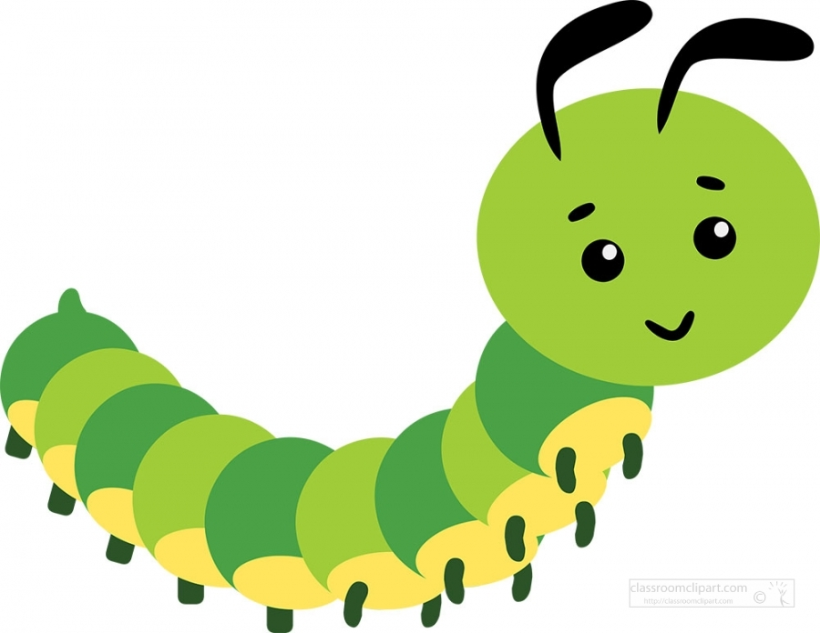

Table of Contents

- Classroom Overview
- Daily Schedule
- Tips for a successful transition
- High/Scope Preschool Key Experiences
- Milestones: 3-Year-Olds
- Milestones: 4-Year-Olds

Welcome

Teachers Rene & Rhiannon would like to welcome your family to the Caterpillar room! We are so excited that your child is in our classroom. They will grow and learn so much this year. This packet will provide you with the basic information for our class. If any questions or concerns come to mind please do not hesitate to chat with us.

Children’s Items

Please Bring

- Coat
- Pair of rain boots
- Gloves
- Hat
- Small nap blanket and lovey/stuffy
- Two changes of weather appropriate clothing
- Family picture to display on our family board
- Picture of face for cubby

Please label all of your children’s clothing and shoes/boots with their name. This will help both the children and adults to keep track of their belongings. Each child has a coat hook, cubby, art file, and a spot for rain boots. Please keep two changes of weather appropriate clothing in your child’s cubby. Coats may be stored on each child’s coat hook and their boots can be placed under the coats. Please refrain from bringing a backpack to school due to limited classroom space.

Oregon weather can be unpredictable and we play outside everyday (including rainy days!!) so your child will need to bring a coat each day and will need a hat and gloves as the weather continues to get colder. If your family needs assistance with purchasing these items please let us know. A small nap blanket and a lovey (small stuffed animal) can fit into the children’s cubbies. Please bring a blanket that can stay at school for the week and then be taken home to wash on Fridays.

Parent Board

Parent information, upcoming events, and daily curriculum information is located on the board above the cubbies. Please check this board daily to see what your child is learning and to keep updated on what is happening.

Curriculum

At Unity we use High/Scope curriculum model, which is a play-based curriculum that emerges from the child’s interests. Teachers plan experiences and interact with children in ways that support their independent thinking, initiative, and creativity. Young children’s cognitive, social, emotional, and physical abilities develop quickly when they can use materials freely and exercise their imaginations. The High Scope learning environment promotes investigation, decision-making, cooperation, persistence, and problem solving.

Every few weeks we web a new Topic of Interest with the children (The web is located on the parent information board). This web is the foundation from where we plan activities, small groups, and how we provision the learning centers in the classroom. For Example: If the current web is “Life Science,” we might play matching and counting games with ocean animals, read books about animals, build/construct various habitats, match animals to the sound/letter they start with, and so much more!

Circle Time

Circle time is a structured part of the day when we read stories, play math and literacy games, do calendar, investigate the weather, and engage in music and movement activities. Our first circle time is at 9:00 am and really begins the academic part of our day. We hope that all children can be here to enjoy this time of the day.

Small Group

This is a time when one teacher meets with 5-7 children to do a teacher-directed activity that works on developing a specific skill. We incorporate math, science, art, social skills, fine motor skills, gross motor skills, and literacy activities during small group time.

Plan-Do-Review

Part of our curriculum is to have the children plan their activity time, where they will plan what they will do and whom they will do those activities with. The children then go about doing their plans. Children are free to move about the room and work, play, and discover the learning centers and special activities that are out daily. After activity time we review what we did with a game in small groups.

We Love Volunteers!!

Please feel free to join us on field trips, lead an activity in the classroom, or just come and spend time volunteering in the classroom! Twice a year we need parents to volunteer for weekend pet care so watch for those pet care sign-ups on the parent board. The sign-up sheet is located at the front desk where you sign your child in and out.

Conferences

We hold parent/teacher conferences in the fall and spring to talk about your child’s progress and set goals for their learning and developing minds and bodies. This is a great time to discuss any questions or concerns you may have. We are also available to chat with you at drop off and pick up time, so please never hesitate to talk with us.

All about Me Board

The All about me board is an opportunity for each child to display pictures and facts about their home life. This way the Caterpillars can get to know each other better. You will receive a note from us when it is your child’s turn to share their life with the rest of the classroom. During September the Caterpillar teachers will take turns sharing photos and facts about themselves on the board.

Caterpillar Daily Routine
8:00-8:30 - Morning Tables & Breakfast
8:30-9:00 - Outside
9:00-9:15 - Morning Circle
9:15-10:00 - Free Choice Time
10:15-10:45 - Snack
10:45-11:30 - Small Groups
11:30-12:00 - Outside
12:15-1:00 - Lunch
1:00-2:30 - Rest Time
2:30-2:45 - Wake Up
2:45-3:00 - Music & Movement
3:00-3:30 - Snack
3:30-6:00 - Outside/Combine

Tips for a smooth transition into Preschool

Morning Drop Off

Starting a new school or moving into a new classroom can be scary for both children and parents. Tears/upsets are a natural response when beginning a new transition but with a little patience we can establish a positive drop off routine.

Be consistent. Change can be tough for everyone. Consistency is key to a successful transition to school.
Going to school on a regular basis with a consistent drop off time will help your child adjust and teach them how to work through negative feelings. Each time you pick them up, remind them that you came to pick them up just as promised, which may ease anxiety the next day.

Talk about what to expect, and listen. Even for adults, the unknown can be scary. Keep explanations simple, but letting your child know what to expect may reduce anxiety. Explain changes to their routine, and try to focus on the positive side of each. Ask your child if they are excited about school, then listen. If they bring up concerns, acknowledge them and address them openly. Talk about healthy ways to ease their fears. If concerns persist or worsen, speak with your child’s teacher about them.

Use drive time to get kids excited. On the way to school, talk about what you know to be the favorite parts of your child’s day. Mention any special friends you know they’ll be excited to see to help remind them of what they like about school. Stay upbeat, and if you sense the conversation is causing more stress, switch to small talk. Try to avoid giving your child any ideas (“Don’t throw a Fit”) or comparing them to other children (Joe never cries at drop-off).

Think about developing a drop-off ritual. Sometimes expecting that special hug or high five along with a consistent phrase (“See you later alligator!”) can make it easier for your child to say goodbye. Once you’ve said your goodbyes, it’s best to leave quickly.

Stay positive and keep goodbyes short and sweet. Children can pick up on your mood. So if you appear nervous and anxious, your child will likely follow suit. Try to appear confident that your child will separate easily – say goodbye cheerfully and matter-of-factly before leaving.

Read books with your child that addresses goodbyes. The Kissing Hand by Audrey Penn and Llama Llama Misses Mama Anna Dewdney are excellent books that can ease separation.
Fostering Independence:

By the age of three you might start hearing the phrase, “I can do it myself!” This is a typical response as your child begins to grow into an autonomous individual. Here at Unity we strive to foster this independence and allow children the opportunities to do as much as they are able by themselves.

Some of these activities include:
- Dressing independently
- Serving themselves at meals (Including pouring water/milk and scraping when finished.)
- Toileting and wiping independently

You can help your children transition smoothly by allowing children to work on these self-help skills at home. Encourage your child to begin to try to put on their own coats and shoes and assist them as needed. Dress children in basic attire such as pull-on pants or Velcro/ slip-on shoes; remember that most children do not tie their own shoes until five or six years of age. By dressing themselves children are learning important skills and independence.

Milestones: 3-Year Olds

Motor Development: Gross Motor
- Walks with an agile, almost adult style
- Runs around obstacles
- Catches large balls and throws overhead
- Climbs ladders; uses slide independently
- Rides tricycle
- Alternates feet when climbing stairs
Motor Development: Fine Motor
- Assembles simple puzzles
- Manipulates clay; finger paint
- Copies simple shapes, such as a cross or circle
- Stacks blocks up to nine high
Language and Thinking Development
- Understands most of what is said and 75 percent of speech is understandable
- Speaks in complete sentences of three to five words
- Matches pictures to objects
- Learns by doing and through the senses
- Understands concepts of “now”, “soon”, and “later’
- Begins to recognize cause-and-effect relationships
Social and Emotional Development
- Follows simple directions’ enjoys helping with household tasks
- Begins to recognize own limits – asks for help
- Likes to play alone, but near other children
- Does not cooperate or share well
- Able to make choices between two things
- Begins to notice other people’s moods and feelings
Tips for Parenting a 3-Year-old
- Transitions are difficult at this age. Provide warning of changes so your child has time to shift gears: “We’re leaving in 10 minutes.”
- Rituals are important. Household routines and schedules give your 3-year old a sense of security.
- Point out colors and numbers in the course of everyday conversation: “That car is blue” or “We made six cupcakes”.
- Encourage independent activity to build self-reliance.
- Provide lots of sensory experiences for learning and developing coordination – sand, mud, finger-paint, puzzles.

Milestones: 4 Year-Olds
Motor Development: Gross Motor Skills
- Running is more controlled; can start, stop, and turn
- Turns somersaults; hops on one foot; gallops
- Can easily catch, throw, and bounce a ball
- Can brush teeth, comb hair, wash, and dress with little assistance
Motor Development: Fine Motor Skills
- Copies crosses and squares
- Prints some letters
- Uses table utensils skillfully
- Cuts on a line
Language and Thinking Development
- Uses a 1,500-word vocabulary; speaks in relatively complex sentences (“Mommy opened the door and the dog ran out”)
- Understands words that relate one idea to another – if, why, when
- Continues to learn through experience and the senses
- Understands, mostly, the difference between fantasy and reality
- Understands number and space concepts – more, less, bigger, in. under, behind
- Thinks literally’ starting to develop logical thinking
- Begins to grasp that pictures and symbols can represent real objects
- Starts to recognize patterns among objects – round things, soft things, animals
- Grasps the concepts of past, present, and future but dose not understand the duration of time.
Social and Emotional Development
- Takes turns, shares, and cooperates
- Expresses anger verbally rather than physically
- Can feel jealousy
- May sometimes lie to protect themselves, but understands the concept of lying
- Enjoys pretending and has a vivid imagination
Tips for Parenting 4-Year-Olds
- 4-year-old crave adult approval. Provide lots of positive encouragement
- Display Calendars and analog clocks to help your child visualize the concept of time
- Play word games to develop his growing vocabulary; overlook his fascination with bad words
- Offer opportunities for sorting, matching, counting, and comparing
- Provide lots of play space and occasions to play with other children

